Grading Document - Lab 4

For your grading of lab 4.

## Pre Lab

1. Encoders
   1. How does an encoder work? What is a quadrature encoder?
      1. Answer:
         1. An encoder tells us a ‘tick’. As the wheel is rotated, basically there are a bunch of magnets that pass by a hall effect sensor that trigger the sensor.
         2. A quadrature encoder is a set of two encoders that are 90 degrees out of phase out of each other.
   2. How can you tell the direction of spin with a quadrature encoder?
      1. Answer: You look at the relationship between the two encoders in the quadrature encoder. If A leads, the encoder is spinning forwards. If B leads, the encoder is spinning backwards.
   3. Do you want use polling or interrupts to read an encoder?
      1. Answer: Ideally, we want them to answer interrupts because it's easy to sense the encoder and do other things, and there is a smaller chance to miss encoder ticks. However a bunch of them will see examples online with polling, and I believe that they will use that to justify polling.
2. Motor Drivers
   1. How does the motor driver work? Why do we need one?
      1. Answer: The motor driver puts out higher current to control the direction and speed of motors ([ref](https://tronixlabs.com.au/news/tutorial-l298n-dual-motor-controller-module-2a-and-arduino)).
   2. What is an h-bridge? Why should we use one?
      1. Answer: An h-bridge is a configuration of relays that will cause current to go through a motor in order to drive the motor forwards and backwards without using negative voltage ([ref](https://en.wikipedia.org/wiki/H_bridge)).
   3. What pins do you have to setup if you wanted to drive one DC motor with an Arduino Uno?
      1. Answer: Depending on the motor channel that you choose to use, you need to set the direction with two digital pins connected to the IN1 and 2 (or 3 and 4) pins. To actually drive the motor you need to connect the EN pin to a pwm pin ([ref](https://tronixlabs.com.au/news/tutorial-l298n-dual-motor-controller-module-2a-and-arduino)).

## Discussion Questions

1. **Discussion Question 1:** Take a picture of the encoder sensor on the back of the motor (underneath the cap). Annotate the picture for the encoder wheel and both hall effect sensors.
   1. Answer: Using picture from encoder product page ([ref](https://www.pololu.com/product/2824#lightbox-picture0J6852)):
      1. The wheel is the encoder wheel, and both hall effect sensors are packaged together in the black rectangle at the encoder wheel’s west (or 9 o clock).

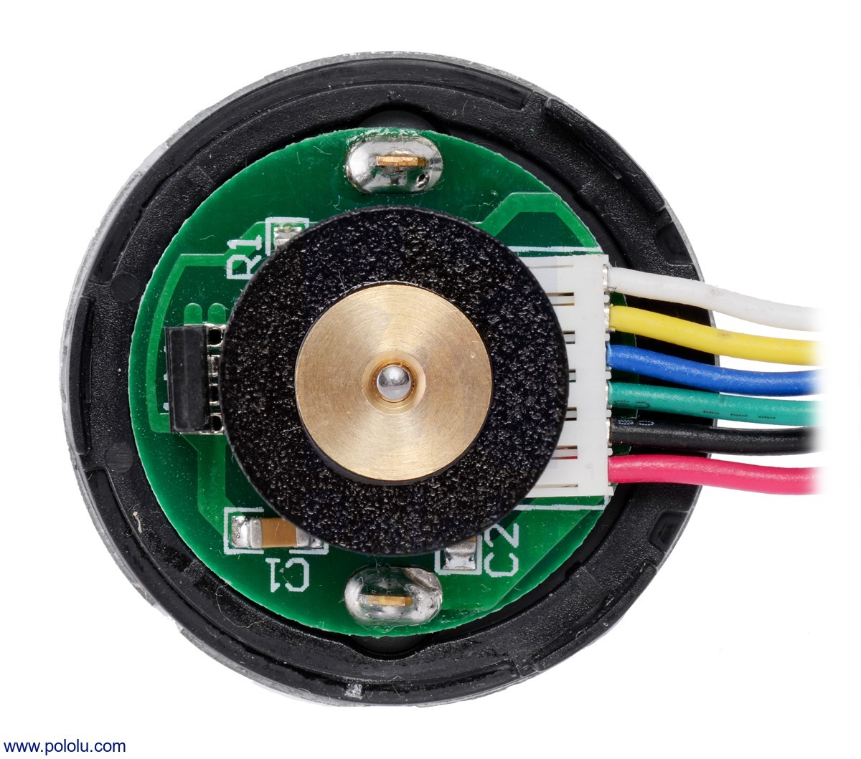

1. **Discussion Question 2:** What do hall effect sensors sense?
   1. Answer: magnetic field.
2. **Discussion Question 3:** Using that information, what is the gear ratio for your motor?
   1. Answer: Check their calculations. The gear ratio should be about 29 or 30.
3. **Discussion Question 4:** How much out of phase are the encoder channels from each other?
   1. Answer: They are 90 degrees out of phase.
4. **Discussion Question 5:** What are the expected readings for points 1, 2, and 3 on each channel?
   1. Answer:
      1. A: High, B: Low
      2. A: High, B: RISING/High
      3. A: RISING/High, B: Low
5. **Discussion Question 6:** What are the expected readings for points 1, 2, and 3 on each channel for this scenario, when the motor is running backwards?
   1. Answer:
      1. A: Low, B: RISING/High
      2. A: RISING/High, B: High
      3. A: RISING/High, B: High
6. **Discussion Question 7:** With the following scenarios in mind, if Channel A triggered on a RISING signal as the encoder ran forwards, what is the state of Channel B?
   1. Answer: Channel B will be low. ( i think it should be **high)**
7. **Discussion Question 8:** If Channel A triggered on a FALLING signal as the encoder ran backwards, what is the state of Channel B?
   1. Answer: Channel B will be low. (i think this should be **high)**
8. **Discussion Question 9:** For average velocity, what should we use for dΘ?
   1. Answer: The total number of ticks for the whole trial.
      1. Students seemed to be confused on this one, I guess we should be lenient.
9. **Discussion Question 10:** For average velocity, what should we use for dt?
   1. Answer: The total time for the whole trial.
      1. Students seemed to be confused on this one, I guess we should be lenient.
10. **Discussion Question 11:** How long does the velocity take to get to zero?
    1. Answer: Taken from their data.
11. **Discussion Question 12:** Qualitatively, how long did it take for the arduino to register zero velocity?
    1. Answer: (For context, this is now with the instantaneous velocity calculations) It was very fast.
12. **Discussion Question 13:** What are the units of your velocity calculations?
    1. Answer: Depends on their implementation. Make sure it makes sense.
13. **Discussion Question 14:** what is velocity at 255 analog write? Does the motor move at all?
    1. Answer: It doesn’t move at all for most people (some people I witnessed it working). Be lenient on this one.
14. **Discussion Question 15:** what is velocity at 255 analog write?
    1. Answer: Won’t give a number because everyone will have variations of their units. Make sure that their findings make sense.
15. **Discussion Question 16:** What is the analogWrite speed resolution?
    1. Answer: I know, I know, its non-linear (question doesn’t make sense) but I told my groups to make a linear approximation. I think next year we will have them do a line of best fit. Be lenient for this one.
16. **Discussion Question 17:** Is the response linear or non-linear?
    1. Answer: Nonlinear. Some groups got a linear response, but there was something wrong with their setup. It was based on the grounding being incorrect.
17. **Discussion Question 18:** At what range of analogWrite command does the motor stay still? What causes this?
    1. Answer: Should be about 0-25/50ish.

### Lab Report Questions

1. Come up with a test to generate a torque-speed curve. Why do we care about the torque-speed curve of a motor?
   1. Answer: It is a basic characteristic of a motor that tells us almost everything about it ([ref](http://lancet.mit.edu/motors/motors3.html#tscurve)).
2. An alternative to an encoder is a rotary potentiometer. What are the advantages that encoders have over rotary encoders?
   1. Answer: I realize that there is a typo. Rotary potentiometers typically have a limited range, and encoders don’t. Encoders give a relative reading (unless they are absolute encoders) and potentiometers don’t. Encoders are also a digital sensor vs. an analog sensor ([ref](http://www.sensorwiki.org/doku.php/sensors/rotary_potentiometer)).
3. Let’s say we have a flag on our motor, just like in lab.
   1. Are the encoders able to tell you the exact position of the flag?
      1. If not, what do you need to know before you can figure that out?
         1. Answer: They are able to tell you the position of the flag as long as you know its starting position. Otherwise you can’t.
   2. What if the arduino were powered off and powered on again?
      1. Again, if not, what do you need to know before you can figure that out?
         1. Answer: You would not unless you knew the starting position.
   3. What type of encoder can give you an absolute position? How do they work?
      1. Answer: An absolute encoder will tell use absolute position. This is accomplished by using a coded encoder wheel (using one with multiple bits) that the encoder will read ([ref](http://www.dynapar.com/technology/absolute-rotary-encoders/), [ref](https://www.posital.com/en/products/absolute-encoders/absolute-vs-incremental.php)).
4. What is odometry? How can encoders be used for it?
   1. Answer: Odometry is estimating where a robot is in the world. Encoders can be used for this by counting the ticks and relating that to a distance, so the robot relatively knows where it is in the world ([ref](https://en.wikipedia.org/wiki/Odometry)).